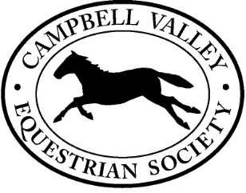Campbell Valley Equestrian Society Membership

CVES is a non-profit organization that is run by volunteers with all revenue generated being put back into the facilities at the park. CVES built and maintains the riding ring, cross-country jumps and the corrals at the park under agreement with the Metro Vancouver. Beyond maintaining the facilities, CVES organizes Dressage, Jumper and Cross-country schooling days. It also runs the exciting 3 day August Horse Trials. Please help us continue our improvements at the park by joining CVES.

Membership entitles you to reduced entry fees at all CVES events.

|  |  |  |
| --- | --- | --- |
| Year: |  | Membership runs from January 1st to December 31st |

**Membership fees**

Each riding member **must** be a current member of Horse Council BC and provide HCBC #

Regular member (current HCBC member) $20.00

|  |  |  |
| --- | --- | --- |
| Supporting member (no reduced entry fees) |  | $5.00 |

Family memberships: first two members pay full rate, each additional member pays $5.00

|  |  |  |
| --- | --- | --- |
| Name | Horse Council BC Membership # | Amount |
|  |  |  |
|  |  |  |
|  |  |  |
|  |  |  |

**Member Information**

|  |  |  |
| --- | --- | --- |
| Address: | | |
| City: | | Postal Code: |
| Phone: | Email: | |

I would like to volunteer: Yes No Maybe (ask me)

Options: Horse Trials Schooling Days Work Parties

Interests: English Western Driving

Dressage Eventing Trail riding Other

Email form and etransfer to [membership@cves.ca](mailto:membership@cves.ca) or mail completed form and cheque made out to CVES to: CVES, c/o Sue Pleasance, 21923 6th Ave, Langley, BC V2Z 1R6